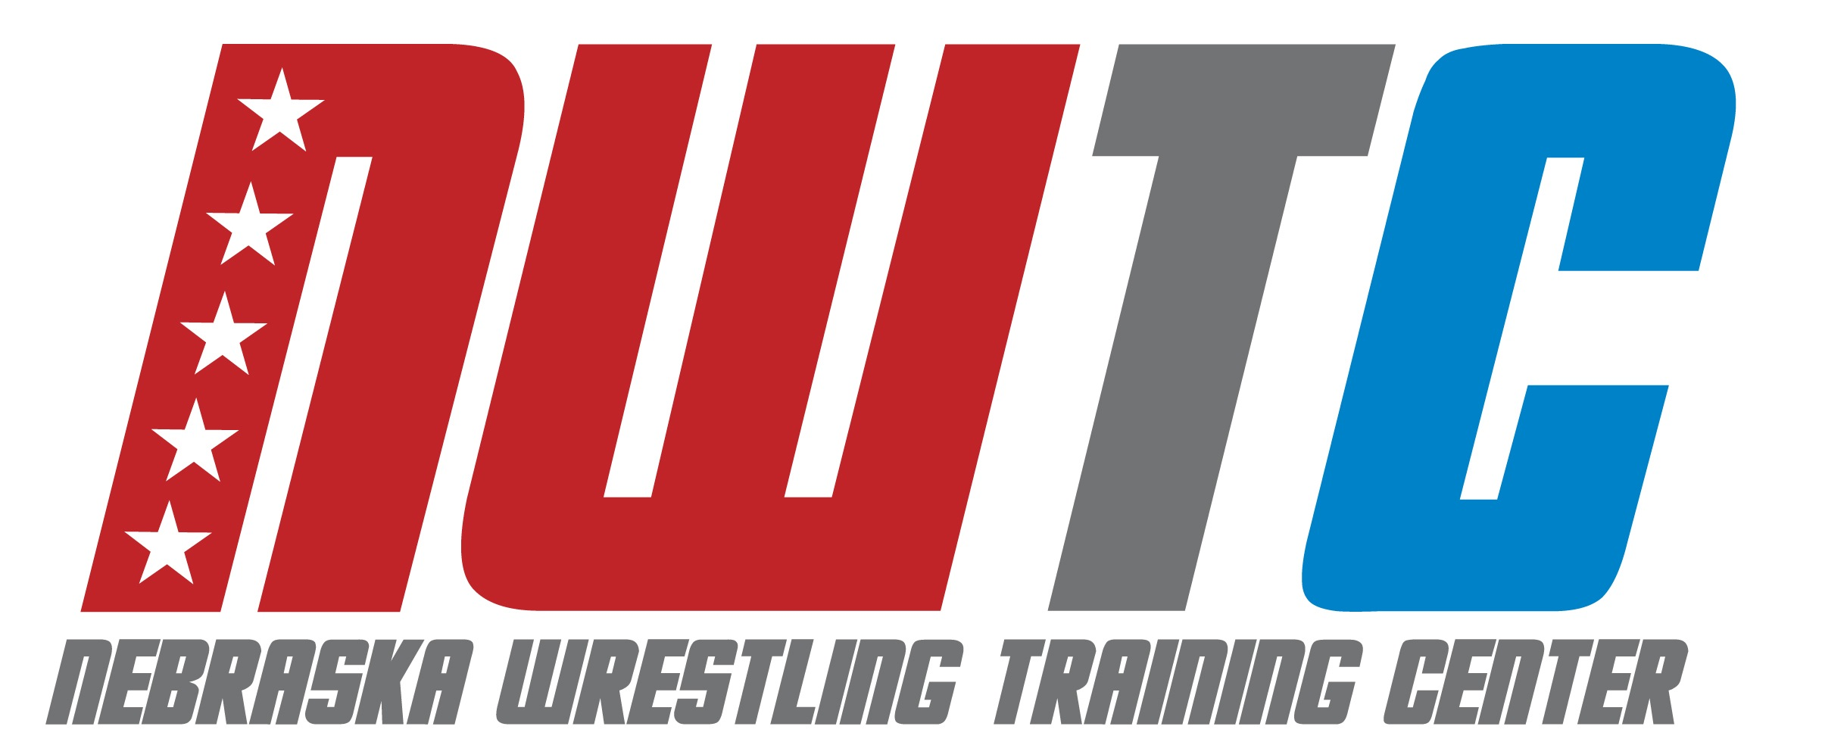

ELITE FREESTYLE CAMP SCHEDULE
**** Meet camp counselor in dorm lobby 30 minutes prior to every session ****

MONDAY, June 22

300-430pm Resident check-in, Harper Hall, 1150 N 14th St, Lincoln, NE 68508
645pm Commuter check-in, Hendricks Training Complex, 1600 Court St., Lincoln, NE 68588
700pm Technique: NU Wrestling Room

TUESDAY, June 23
630-730am Breakfast
1000am Technique: NU Wrestling Room
11-1200pm Lunch
300pm Drill + Live wrestling: NU Track
500-600pm Dinner
700pm Film Review – Dorm Lounge

WEDNESDAY, June 24
630-730am Breakfast
1000am Technique: NU Wrestling Room
11-1200pm Lunch
300pm Drill + Live Wrestling: NU Track 500-600pm Dinner
700pm Mindset Talk – Dorm Lounge

THURSDAY, June 25
630-730am Breakfast
1000am Technique: NU Wrestling Room
11-1200pm Lunch
300pm Drill + Live wrestling: NU Track 500-600pm Dinner
700pm Games: Memorial Stadium

FRIDAY, June 26
630-730am Breakfast
900am Technique: NU Wrestling Room
1030am Check-out

